姓名： 报考专业： 准考证号码： | 密封线内不要写题
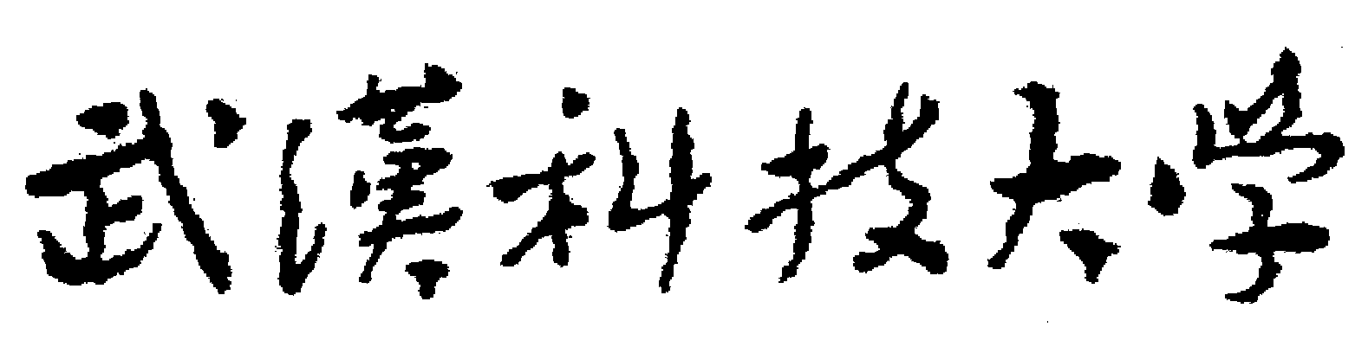2020年全国硕士研究生招生考试初试自命题试题
科目名称：写作与翻译（A卷□B卷）科目代码：858
注意：所有答题内容必须写在答题纸上，写在试题或草稿纸上的一律无效；考完后试题随答题纸交回。
Part One Translation (75 points)
I. Translate the following into Chinese. (40 points, 8 points for each item)
- There are two Sorts of People in the world, who with equal Degrees of Health, & Wealth, and the other Comforts of Life, become, the one happy, and the other miserable. This arises very much from the different Views in which they consider Things, Persons, and Events; and the Effect of those different Views upon their own Minds.

- The great charm, however, of English Scenery is the moral feeling that seems to pervade it. It is associated in the mind with ideas of order, of quiet, of sober, well-established principles, of hoary usage and reverend custom.
- As families move away from their stable community, their friends of many years, and their extended family relationships, the informal flow of information is cut off, and with it the confidence that information will be available when needed and will be trustworthy and reliable.

- Unless one is wealthy there is no use in being a charming fellow. The poor should be practical and ordinary. It is better to have plenty of money than to be attractive. These are the great truths of modern life which he never realized.

- By definition, this way of life is parasitic. In one way or another, its practitioners batten on the society which they scorn and in which they refuse to take any responsibility.
II. Translate the following into English. (35 points, 7 points for each item)
- 小说的语言素朴，却不乏表现力，对于故事的构想与讲述都能见出作者的功力。

- 我欲与君相知, 长命无绝衰。山无陵, 江水为竭, 冬雷震震, 夏雨雪, 天地合, 乃敢与君绝。

- 中国的改革发端于农村，目的在于调节农民和土地之间的关系。1978年之前，数亿中国人还在为温饱问题发愁，如今，经过40年的发展，中国有7亿多农村人口实现脱贫。
- 儒家思想的代表之一墨子崇尚“大爱”, 或者更恰当地说，主张“尚他、尚物”。从利他主义角度来看，这有助于人与人、国与国、人与自然之间达成积极和谐的统一状态。
- 和他们在一起我们觉得最舒服，自然而然我们也愿意和这样家境相仿，门当户对的人结交。
Part Two Writing (75 points)
I. Write an email on the basis of the following information. (25 points)
Xiao Li, one of your closest friends, is going to graduate from university soon. He is wondering whether he should further his study at home or abroad.
Please write her an email and give your own advice. You should write at least 150 words.
Do NOT write your address and your real name.
II. Write an essay on the basis of the following information. (50 points)
It’s smart to hire people smarter than you. This is the top advice from Jack Ma, Executive Chairman Alibaba Group Holding. “When I hire people, I hire the people who are smarter than I am. People who four, five years later could be my boss. I like people who I like, who are positive and who never give up.”
Please give your own opinions. You should write at least 300 words.
For the above two writing tasks, grading will be based on content, organization, language and appropriateness. Failure to follow the above instructions may result in a loss of marks.
Write your compositions on the ANSWER SHEET

The End

