姓名： 报考专业： 准考证号码： | 密封线内不要写题
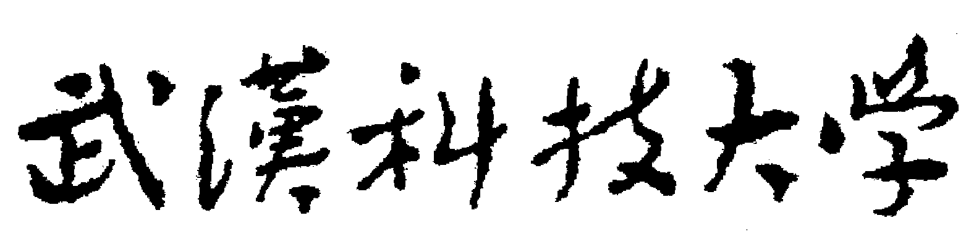2020年全国硕士研究生招生考试初试自命题试题
（ B 卷)
科目代码： 857 科目名称： 英美文学基础
注意：所有答题内容必须写在答题纸上，写在试题或草稿纸上的一律无效；考完后试题随答题纸交回。
I. Find out the matches from column B for items in column A (注意：B栏中有两个多余的干扰选项). Write the corresponding matches (e.g., 1—R, 5—B, etc.) on your answer sheet. (共20小题，每小题1分，共20分)
A |  | B
1 | Robert Burns | A | “A Modest Proposal”
2 | Toni Morrison | B | Poor Richard’s Almanac
3 | William Carlos Williams | C | Oliver Twist
4 | John Fowles | D | The Portrait of a Lady
5 | Ralph W. Emerson | E | Leaves of Grass
6 | Oscar Wilde | F | The Golden Notebook
7 | T. S. Eliot | G | Death of a Salesman
8 | Eugene G. O’Neill | H | Howl
9 | Benjamin Franklin | I | To the Lighthouse
10 | Jonathan Swift | J | The Red Wheelbarrow
11 | Arthur Miller | K | Dubliners
12 | Jane Austen | L | Recitatif
13 | Doris Lessing | M | Mansfield Park
14 | Robert Frost | N | Walden
15 | James Joyce | O | The French Lieutenant’s Woman
16 | Walt Whitman | P | A Witness Tree
17 | Henry James | Q | “Scots, Wha Hae”
18 | Virginia Woolf | R | As I Lay Dying
19 | Allen Ginsburg | S | “Tradition and the Individual Talent”
20 | Charles Dickens | T | Bound East for Cardiff
 |  | U | The Picture of Dorian Gray
 |  | V | The American Scholar
II. Explain the following literary terms or characters with adequate details. Write your answers on your answer sheet. (共6小题，每小题5分，共30分)

1. Aestheticism 2. Mr. Bingley (in Pride and Prejudice)
3. The Gilded Age 4. Tom (in A Woman on a Roof)
5. The Beat Generation 6. Chillingworth (in The Scarlet Letter)

III. Read the following two poems carefully and write your answers to the corresponding questions on your answer sheet. (共8小题，每小题5分，共40分)

Poem 1: The Flea (excerpt)
……
Oh stay, three lives in one flea spare,
Where we almost, nay more than married are.
This flea is you and I, and this
Our marriage bed and marriage temple is;
Though parents grudge, and you, we are met,
And cloisered in these living walls of jet.
Though use make you apt to kill me
Let not to that, self-murder added be,
And sacrilege, three sins in killing three.

Questions 1 to 4 are based on the above poem.（每小题5分）

1. Who is the author of the poem? What are the features of his poetry as reflected in this poem?

2. What Christian metaphors do you find in this poem? Is it a religious poem? Why?

3. What is the real purpose of the man to say that in killing the flea “thou” are actually killing three lives?

4. What is the man’s intention throughout the poem? Will the woman satisfy the man’s request? Why?

Poem 2: One's Self I Sing (by Walt Whitman )

One's Self I sing, a simple separate person,
Yet utter the word Democratic, the word En-Masse.

Of physiology from top to toe I sing,
Not physiognomy alone nor brain alone is worthy for the Muse,
I say the Form complete is worthier far,
The Female equally with the Male I sing.

Of Life immense in passion, pulse, and power,
Cheerful，for freest action form'd under the laws divine,
The Modern Man I sing.

Questions 5 to 8 are based on the above poem.（每小题5分）

5. What is the significance of singing about one’s self?

6. What is the difference between physiology and physiognomy?

7. How do you understand “the Modern Man” Whitman sings?

8. What are Whitman’s contributions to modern poetry?

IV Answer the following questions with adequate details from the works related. Write your answers on your answer sheet. (共3小题，每小题20分，共60分)

1. In Jane Eyre, Jane once said that “Life appears to me too short to be spent in nursing animosity or registering wrongs.” How is it true as you can find in the life of Jane in the novel? Does her attitude towards “animosity” or “wrongs” remain the same throughout the novel? Why and how?

2. T. S. Eliot once wrote that “Poetry may make us from time to time a little more aware of the deeper, unnamed feelings which form the substratum of our being, to which we rarely penetrate; for our lives are mostly a constant evasion of ourselves.” How is it the case in your understanding of his poem The Waste Land? What does the poem reveal about “our being” and “ourselves”?

3. What does the farm mean to Cabot, Eben, and Abbie respectively in Desire Under the Elms? Why are they attracted to each other?

